Gathering Table
a Faith Community
in the Anglican Church of Canada

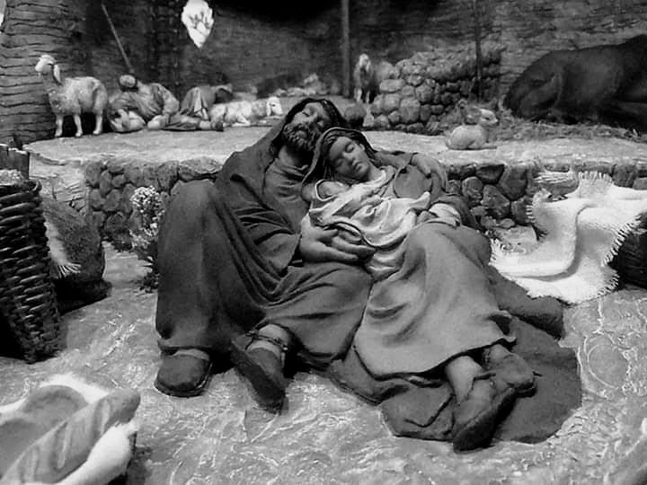

‘.Greetings In The Name Of The Risen Lord !
Been – Sa – gen, Jem na do waky gan ning

Gathering Table

a Faith Community in the Anglican Church of Canada

Officiant & Preacher: The Rev’d George Porter, D. Phil.

The Liturgy of the Word for Christmas Eve

December 24, 2020 7:00 p.m.

Welcome To Gathering Table
+ + + + + + + + + + + + + +

For thousands of years, First Nations people have walked on this land, and relationship with the land is at the centre of life and spirituality. We are gathered as treaty people on the traditional territory of the Anishnaabeg of the Fort William First Nation and acknowledge this people’s stewardship of this land through the ages.

pre-service music

Carol: Once In Royal David’s City

I bring you good news of a great joy which will come
to all the people, for to you is born this day
a Saviour, Christ the Lord. Luke 2. 10 - 11

Hark! The Herald Angels Sing Donna & Ted

The Lighting of the Christ Candle Love
Song of the First-Born
Colossians 1. 15 – 20

Christ is the image of the unseen God,
the first-born of all creation,
for in him were all things made,
in heaven and on earth.

Through him and for him were all things made,
before all he exists, holds all things in one.
The Church is his body, and he is its head.

He is the beginning, the first-born from the dead;
in all things he alone is supreme.
God made all his fullness to dwell in him,
to reconcile through him all creation to himself,
everything on earth and everything in heaven,
all gathered into peace by his death on the cross.

Carol: O Come, All Ye Faithful

Gathering of the Community:

In the name of the Father and of the Son and of the Holy Spirit.

Blessed be the Lord, the God of Israel,
May all the earth be filled with his glory.
Light has sprung up for the righteous,
And joyful gladness for those who are true-hearted.
Glory to God in the highest,
And peace to his people on earth.

Almighty God,
to you all hearts are open, all desires known, and from you no secrets are hidden. Cleanse the thoughts of our hearts by the inspiration of your Holy Spirit, that we may perfectly love you, and worthily magnify your holy name; through Christ our Lord. Amen.

Let us continue in prayer together, saying:
Creator, we give you thanks for all you are and all
you bring to us for our time within your creation.
In Jesus, you place the Gospel in the centre of the
sacred circle through which all of creation is
related. You show us the way to live a generous
and compassionate life. Give us your strength to
live together with respect and commitment as we
grow in your Spirit, for you are God, now and
forever. Amen

Collects for Christmas Eve & Christmas

Eternal God, this holy night is radiant with the brilliance of your one true light. As we have known the revelation of that light on earth, bring us to see the splendour of your heavenly glory;
through Jesus Christ our Lord, who is alive and reigns with you and the Holy Spirit, one God, now and for ever. Amen
O God our Father, whose Word has come among us in the Holy Child of Bethlehem, may the light of faith illumine our hearts and shine in our words and deeds; through him who is Christ our Lord, who lives and reigns with you and the Holy Spirit, one God, now and for ever. Amen

The Proclamation of the Word
First Reading is from
Isaiah 9: 2 - 7
The people who walked in darkness
have seen a great light;
those who lived in a land of deep darkness—
on them light has shined.
³ You have multiplied the nation,
you have increased its joy;
they rejoice before you
as with joy at the harvest,
as people exult when dividing plunder.
⁴ For the yoke of their burden,
and the bar across their shoulders,
the rod of their oppressor,
you have broken as on the day of Midian.
⁵ For all the boots of the tramping warriors
and all the garments rolled in blood
shall be burned as fuel for the fire.
⁶ For a child has been born for us,
a son given to us;
authority rests upon his shoulders;
and he is named
Wonderful Counselor, Mighty God,
Everlasting Father, Prince of Peace.
⁷ His authority shall grow continually,
and there shall be endless peace
for the throne of David and his kingdom.
He will establish and uphold it
with justice and with righteousness
from this time onward and forevermore.
The zeal of the Lord of hosts will do this.

This is the Word of the Lord
Thanks be to God
Psalm 96

Praise to God Who Comes in Judgment
¹ O sing to the Lord a new song;
sing to the Lord, all the earth.
² Sing to the Lord, bless his name;
tell of his salvation from day to day.
³ Declare his glory among the nations,
his marvelous works among all the peoples.
⁴ For great is the Lord, and greatly to be praised;
he is to be revered above all gods.
⁵ For all the gods of the peoples are idols,
but the Lord made the heavens.
⁶ Honor and majesty are before him;
strength and beauty are in his sanctuary.
⁷ Ascribe to the Lord, O families of the peoples,
ascribe to the Lord glory and strength.
⁸ Ascribe to the Lord the glory due his name;
bring an offering, and come into his courts.
⁹ Worship the Lord in holy splendor;
tremble before him, all the earth.
¹⁰ Say among the nations, “The Lord is king!
The world is firmly established; it shall never be moved.
He will judge the peoples with equity.”
¹¹ Let the heavens be glad, and let the earth rejoice;
let the sea roar, and all that fills it;
¹² let the field exult, and everything in it.
Then shall all the trees of the forest sing for joy
¹³ before the Lord; for he is coming,
for he is coming to judge the earth.
He will judge the world with righteousness,
and the peoples with his truth

Second Reading is from
Hebrews 1: 1 - 12
God Has Spoken by His Son
1 Long ago God spoke to our ancestors in many and various ways by the prophets, ² but in these last days he has spoken to us by a Son,^{[a]} whom he appointed heir of all things, through whom he also created the worlds. ³ He is the reflection of God’s glory and the exact imprint of God’s very being, and he sustains^{[b]} all things by his powerful word. When he had made purification for sins, he sat down at the right hand of the Majesty on high, ⁴ having become as much superior to angels as the name he has inherited is more excellent than theirs.
The Son Is Superior to Angels
⁵ For to which of the angels did God ever say,
“You are my Son;
today I have begotten you”?
Or again,
“I will be his Father,
and he will be my Son”?
⁶ And again, when he brings the firstborn into the world, he says,
“Let all God’s angels worship him.”
⁷ Of the angels he says,
“He makes his angels winds,
and his servants flames of fire.”
⁸ But of the Son he says,
“Your throne, O God, is^{[c]} forever and ever,
and the righteous scepter is the scepter of your^{[d]} kingdom.
⁹ You have loved righteousness and hated wickedness;
therefore God, your God, has anointed you
with the oil of gladness beyond your companions.”
¹⁰ And,
“In the beginning, Lord, you founded the earth,
and the heavens are the work of your hands;
¹¹ they will perish, but you remain;
they will all wear out like clothing;
¹² like a cloak you will roll them up,
and like clothing^{[e]} they will be changed.
But you are the same,
and your years will never end.”

This is the Word of the Lord
Thanks be to God

A Gradual Carol: ‘Twas in the Bleak Midwinter’

The Lord be with you.
And also with you.

The Holy Gospel of our Lord Jesus Christ according to
Luke 2: 1 - 20

GLORY TO YOU LORD JESUS CHRIST
This is The Gospel of Christ

PRAISE TO YOU, LORD JESUS CHRIST

Sermon: George
‘Make Room’ – Casting Crowns

A Time of Reflection
Silent Night, Donna & Ted

The Nicene Creed
Let us confess our faith, as we say:
We believe in one God,
the Father, the Almighty,
maker of heaven and earth,
of all that is, seen and unseen.

We believe in one Lord, Jesus Christ,
the only Son of God,
eternally begotten of the Father,
God from God, Light from Light,
true God from true God,
begotten, not made,
of one being with the Father.
Through him all things were made.
For us and for our salvation
he came down from heaven:
by the power of the Holy Spirit
he became incarnate from the Virgin Mary,
and was made man.
For our sake he was crucified
under Pontius Pilate;
he suffered death and was buried.
On the third day he rose again
in accordance with the scriptures;
he ascended into heaven
and is seated at the right hand of the Father.
He will come again in glory
o judge the living and the dead,
and his kingdom will have no end.

We believe in the Holy Spirit,
the Lord, the giver of life,
who proceeds from the Father.
With the Father and the Son
he is worshipped and glorified.
He has spoken through the prophets.
We believe in one holy catholic
and apostolic Church.
We acknowledge one baptism
or the forgiveness of sins.
We look for the resurrection of the dead,
and the life of the world to come. Amen.

The Prayers & the Litany of the Incarnation

Let us pray.
Remember, Lord, your one holy catholic and apostolic Church, redeemed by the blood of your Christ. Reveal its unity, guard its faith, and preserve it in peace.

Remember Archbishop Anne and all who minister in your Church.

Remember all your people, and those who seek your truth.

Remember those who have asked our prayers and others known to you.

Remember all who have died in the peace of Christ, and those whose faith is known to you alone; bring them into the place of eternal joy and light. And grant that we may find our inheritance with the blessed Virgin Mary, with patriarchs, prophets, apostles, and martyrs, and all the saints who have found favour with you in ages past.
We praise you in union with them and give you glory through your Son Jesus Christ our Lord.
So in joy and humility let us pray to the creator of the universe, saying, “Lord, grant us peace.”

By the good news of our salvation brought to Mary by the
angel, hear us, O Lord.
Lord, grant us peace.

By the mystery of the Word made flesh, hear us, O Lord.
Lord, grant us peace.

By the birth in time of the timeless Son of God, hear us, O Lord.
Lord, grant us peace.

By the manifestation of the King of glory to the shepherds and magi, hear us, O Lord.
Lord, grant us peace.

By the submission of the maker of the world to Mary and
Joseph of Nazareth, hear us, O Lord.
Lord, grant us peace.

By the baptism of the Son of God in the river Jordan, hear us, O Lord.
Lord, grant us peace.
Grant that the kingdoms of this world may become the
kingdom of our Lord and Saviour Jesus Christ; hear us, O
Lord.
Lord, grant us peace.

Confession and Absolution
Dear friends in Christ,
God is steadfast in love and infinite in mercy; God welcomes sinners and invites them to the table.
Let us confess our sins, confident in God’s forgiveness.

Most merciful God,
we confess that we have sinned against you
in thought, word, and deed,
by what we have done,
and by what we have left undone.
We have not loved you with our whole heart;
we have not loved our neighbours as ourselves.
We are truly sorry and we humbly repent.
For the sake of your Son Jesus Christ,
have mercy on us and forgive us,
that we may delight in your will,
and walk in your ways,
to the glory of your name.

Almighty God have mercy upon us, pardon and deliver us from all our sins, confirm and strengthen us in all goodness, and by the power of the Holy Spirit, keep us in eternal life; through Jesus Christ our Lord. Amen.
The Peace
The Peace of the Lord be always with you
And also with you

And now, as our Saviour Christ has taught us, we are bold to say:

The Lord’s Prayer
Notawinan misiwe e ayayan Our Father, who art in heaven
Kiwiyowin Ke natenitawan hallowed be thy name,
Weticipaniew kit otenawiwin thy kingdom come,
Mina tawi oticipaniw thy will be done,
Kakina kewan ka itenitaman on earth, as it is in heaven.
Tapishoic kicikishikok ishi Give us this day our daily bread.
Mininan oma anoc kakishikak And forgive us our trespasses,
Ke oci pimatisiyak min as we forgive those who trespass
Ashenamawinan tato kewana against us.
Ita kashi macitotamak and lead us not into temptation,
Ninanan e ashenamawakicik but deliver from evil.
Aniki ka wanitotakoyak For thine is the kingdom,

Wiciinan eka tapimoteyak the power, and the glory,
Kotenimiko winik ninanan for ever and ever.
Maka mita kwenamawinan eka
Macatisiwini kekwana
Kina ka tipenitan kakike
Sokatisiwin keshtenitakwak

The Blessing

May the Lord give us firm faith, unwavering hope,
perfect charity, and pour into our hearts
the spirit of wisdom and understanding,
the spirit of counsel and spiritual strength,
the spirit of knowledge and true godliness,
and the spirit of a holy awe in all God’s works.
May light eternal, shine in our hearts:
Power eternal, deliver us from evil:
Wisdom eternal, scatter the darkness of ignorance:
Might eternal, have mercy on us.
God grant that we may ever seek God’s face,
with all our heart and soul and strength;
and keep us in God’s holy presence,
with the blessing of the Father and of the Son and of the Holy Spirit. Amen.

Announcements:

Closing Carol: Joy to the World

Dismissal: God has come among us. Let us go forth, walking in hope, faith joy and peace by the Light in the midst of us, to love and serve God and all God’s creatures.

Thanks be to God.
Alleluia ! Alleluia ! Alleluia !

Readings for The First Sunday After Christmas
Isaiah 61: 10 – 62:3 Psalm 148
Galatians 4: 4 - 7 Luke 2: 22 - 40

Anglican Cycle of Prayer - please pray for: Ezo (South Sudan) The Rt Revd John Kereboro Zawo
Faisalabad (Pakistan) The Rt Revd John Samuel
Falkland Islands (Parish of) (Falkland Islands) The Rt Revd Timothy Thornton (Diocesan Bishop)

Anglican Lutheran Cycle of Prayer –
please pray for:
ACC Director Joe Vecsi and the staff of Communications and Information Resources; Director Hannah Goschy and the staff of Financial Management and Administration
ELCIC Rev. Lyle McKenzie, Assistant to the National Bishop for Worship

Diocesan Cycle of Prayer: please pray for: The Church of the Holy Manger, Barkway, The Rev. Heather Manuel
Parish Cycle of Prayer - please pray for our own church members: Adrienne Morris, Tom and Dora Morris, Charles and Marion Morris, Rosalie Hardisty Morris, Mark Myers, Dorothy Nesbitt, Len Norris, Garth and Brenda O'Neill, Cindy Papassay, Henry Parise, Marjorie (Midge) Peel, Richard Pepper, Sheila Pepper, Nancy and Bob Polhill, George and Nancy Porter, Dr. Michelle Proudfoot, Chris and Laura Pyhtila, David and Erminie Reid, Matthew and Desiree Reilly, Madison and Owen

Please pray for: Our young people in Junior High School, High School, College and University who are struggling academically, social and mentally, as well as with understanding their own identities.
A grace note from www.thunderbay-northshoreanglicans.com

Christmas is most truly Christmas when we celebrate it by giving the light of love to those who need it most.
Ruth Carter Stapleton

Prayer requests from Arch Bishop Anne:
“Please join the bishops of our province in holding our province and our whole world in prayer during this time of crisis, especially those who are afflicted with this coronavirus. Pray especially for researchers, policymakers, frontline workers, and for all those who are caring for those who are sick, as well as for those who have died and those who mourn.”
“Continue to pray for those who are most deeply affected by COVID-19 - frontline workers, hospital staff, those who are stranded and unable to return to their homes from abroad, those who are isolated further because of the new restrictive measures in place, and those who have been diagnosed with COVID -19 and their families and loved ones.”
Gathering Table Prayer Chain
During this time of social isolation and uncertainty, it is more important than ever to pray for one another. If you would like to be a part of the Gathering Table prayer chain or you have any needs or concerns that you would like placed on the prayer chain please contact Sheila Chisholm at chisholmsheilak@gmail.com
or text /phone 306-240-0771.
Reminder about Visitations:
Pastoral care visits will be continue to be restricted to emergency situations – please call the office or the Rectory if such a situation arises.

Dear Parishioners:
At this time as we move back into the closing of the building and in-person re-gathering for Sunday worship services … Here are some other things to take note of:
- The building will remain essentially closed indefinitely, though phone calls will be answered during office hours. All gatherings, events or meetings (apart from worship services) must either be postponed or conducted by means of various internet tools.
- The Food Cupboard will operate every second and fourth Sunday of the month in its present modified format. No emergency food parcels will be distributed during this time.
- Pastoral visitation is drastically restricted. In emergency situations please call the office or the Rectory. We realize that, despite the focus on this crisis and the cutting back on medical and social services, other things still go on – and some things get worse. Isolation is hard for many people for different reasons, not only physically, but relationally, emotionally and spiritually. We want to do what we can to help.
- Remember to pray especially for leaders and for those who must engage in heroic forms of ‘risky behaviours’: medical personnel, emergency responders, those who deal with the dead and their families, those who keep vital services operating, and those mostly unseen people who enable these others to keep going.
Sunday Sermons: Sunday service can be viewed on the Gathering Table website http://gatheringtable.ca and on the Gathering Table Facebook page. The whole service will be live streamed at 10 a.m. Sunday at the link http://gatheringtable.ca Please Note You may be visible on the online stream

Church Calendars 2021 – Call the office if you would like to get one . Calendars are $5.00 each if picked up, or $7.00 if you would like us to mail them to you.

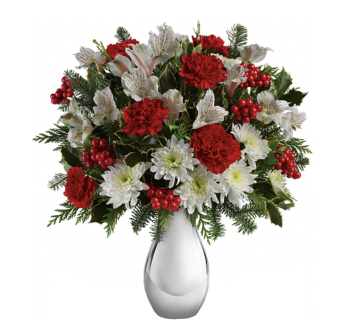 CHRISTMAS FLOWERS

To the Glory of God and….
In thanksgiving for the lives lived and memories cherished of husband/father Leonard Hartley, son/brother Michael Hartley, son-in-law/husband Joel Mutungu-Ngugi.
With love from Diane Hartley and Linda Hartley-Ngugi.

In thanksgiving for all our many memories of
Robert Johnson, Helen and John Wolfe

Love always Carl and Roberta Wolfe and Families

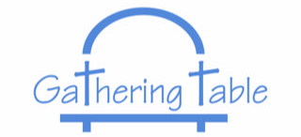
a Faith Community in the Anglican Church of Canada

228 Pearl Street, Thunder Bay, Ontario P7B 1E4
Email: office@gatheringtable.ca
Web: http://gatheringtable.ca
Office: 345-6898
Hall: 345-6088
Service Time: Sunday at 10:00 am
Food Bank Open: 2nd and 4th Sundays starting at 11:30 am
Pastor: The Rev. Canon George M. Porter, D.Phil.
Phone: 626-9650
Mobile: 355-5454
Email: porter.george@gmail.com
Honorary Assistant: The Rev. Gail M. Clifton, M.Div.
Phone: 768-9865 Email: gailx2@ shaw.ca
Lay Readers: Kim Bienvenue, Rose Jardine, Brenda O’Neill, Jim Sutton. Frances Bennett-Sutton
Rector’s Warden: Marg Boone
Deputy Rector’s Warden: Marjorie Tutkaluk
People’s Warden: Jim Sutton
Deputy People’s Warden: Sheila Chisholm
Music Ministry at Gathering Table
Co – Music Directors: (Organist)
Donna Hamill (Pianist)
Archbishop Anne's Motto for 2020

“In the same way, let your light so shine before others
that they may see your good works
and give glory to your Father in heaven.”
(Matthew 5.16)

“

